SCHOOL NAME: _______________________ NAME: ____________________________________

SHIRE HIGHLANDS EDUCATION DIVISION
2025 MALAWI SCHOOL CERTIFICATE OF EDUCATION MOCK
EXAMINATION

CHEMISTRY
Subject Number: M038/I
Wednesday, 2nd April Time Allowed: 2 hours
8:00-10:00am

PAPER I
(100 Marks)

THEORY

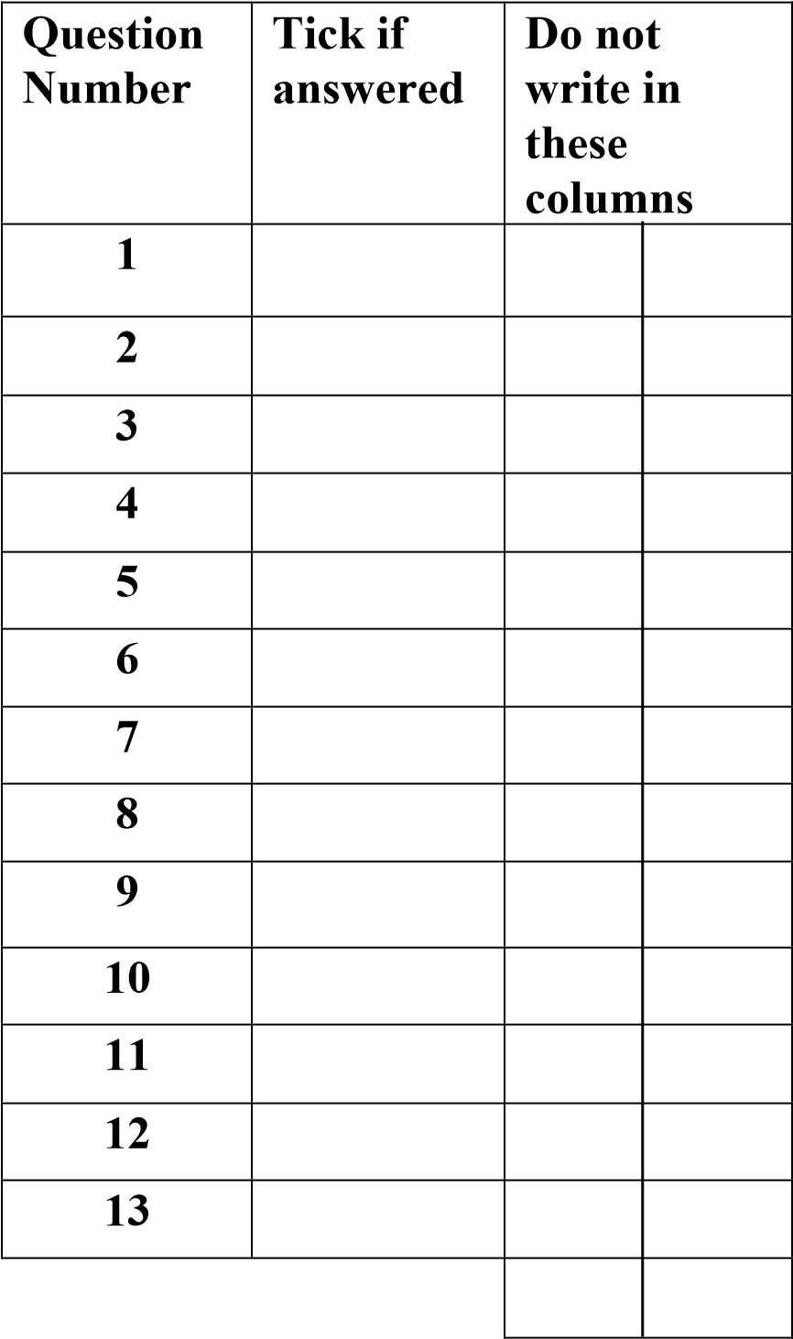
Instructions
- This paper contains 8 printed pages.
Please check.

- Write your Name and School at the top of each page of this question paper.

- This paper contains two sections, A and B. In Section A there are ten short answer questions while Section B there are three restricted essay questions.

- Use of electronic calculators is allowed.

- The maximum number of marks for each answer is indicated against each question.

- In the table provided on this page, tick against the number of question you have answered.
- Hand in your question paper to the invigilator when time is called to stop writing.

© 2024 SHED MOCK Turn over/…
Section A (70 marks)
Answer all the ten questions in this section in the spaces provided.

- a. What is a precipitate?
__________________________________________________________________________
___________________________________________________________________(1 mark)
  - Table 1 show results that were obtained for testing some cations using aqueous ammonia solution.
Cation | 3 drops aqueous ammonia solution | Excess aqueous ammonia solution
Cu²⁺ | X | Soluble
Fe²⁺ | Green precipitate | Y
Al³⁺ | White precipitate | Insoluble
Table 1
- Write the results represented by letter
X: ________________________________________________________________
Y: ________________________________________________________________
(2 marks)
- How can white precipitate formed by aluminium be removed?
______________________________________________________________(1 mark)
  - Mention one way of treating waste using heat. ____________________________________________________________________(1 mark)
- a. State the property that enable metals to be drawn into wires
____________________________________________________________________ (1 mark)
  - Give any two chemical phosphorous.
_______________________________________________________________________________________________________________________________________________ (2 marks)
  - Why is nitrogen gas inert at room temperature?
_______________________________________________________________________________________________________________________________________________(2 marks)
- a. Why are most covalent compounds that are in liquid form volatile?
_______________________________________________________________________
_______________________________________________________________________
(2 marks)
  - Give any two properties of alloy.
___________________________________________________________________________
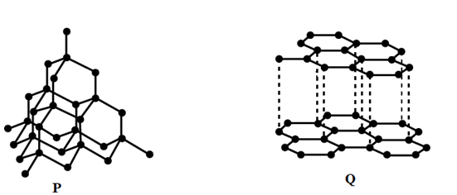
__________________________________________________________________(2 marks)
c. Figure 1 shows allotropes of carbon labelled P and Q

Figure 1
- Identify the allotrope that is soft and slippery.
_______________________________________________________________ (1 mark)
- Which allotrope has high melting point. Give a reason for your answer.
_______________________________________________________________ (1 mark)
- Explain your answer in 3 c. (ii).
_______________________________________________________________________________________________________________________________________________________________________________________________________________ (3 marks)
- a. Name the functional group of alkanals and alkanones. _______________________________________________________________________(1 mark)
  - An organic compound has the following general formula C_{n}H_{2n+1} COOH
- Name one source of the compound.
_________________________________________________________________________
(1 mark)
- Write down condensed formula of the compound with 4 carbon atoms.
_________________________________________________________________________
(1 mark)
- Give a reason why the organic compound dissolve in water.
__________________________________________________________________________________________________________________________________________________
(3 marks)
- a. State two ways of expressing concentration of a solution.
________________________________________________________________________________________________________________________________________________________
(2 marks)
b. Calculate the molarity of sodium hydroxide (NaOH) made by dissolving 120.0g of NaOH in water and making the volume to 4.0dm³. (RAM: Na = 23, O = 16, H = 1)

(4 marks)
Continued/…
c. Work out the empirical formula of Copper Oxide if 2.12g of Copper metal burns in Oxygen to produce 2.65g of copper oxide. (RAM: Cu=63.5, O=16).

(5 marks)
- a. Define a base according to Bronsted – Lowry theory.
____________________________________________________________________(1 mark)
b. Table 2 below shows some oxides and results of their reaction with an acid and base.
Oxide | Reaction with acid | Reaction with base
A | Water + salt | No reaction
B | No reaction | Water + salt
C | Water + salt | Water + salt

Table 2
- Identify oxides as
Non-metallic oxide : _______________________________________(1 mark)
Metallic oxide : _______________________________________(1 mark)

- Describe how the strength of an oxide A be determined using universal indicator paper?
________________________________________________________________________________________________________________________________________________________________________________________________________________________________________________________________________________________
(4 marks)
- a. What are isomers
________________________________________________________________________________________________________________________________________________(1 mark)
  - Figure 2 below shows structure of some organic compounds A, B, C, D and E.
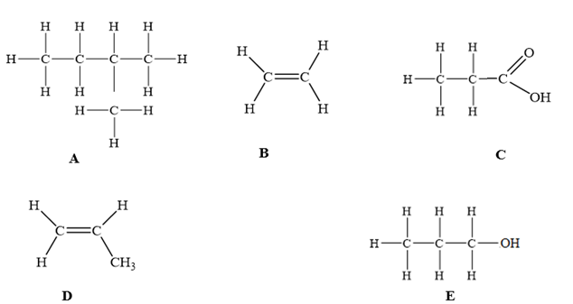
Figure 2
- Name compound A.
________________________________________________________________________
(1 mark)
- Name one oxidising agent that is used to convert compound E to produce compound C.
________________________________________________________________________
(1 mark)
- Explain why compound D does not conduct electricity?
________________________________________________________________________________________________________________________________________________________________________________________________________________________________________________________________________________________________
(2 marks)
- a. Explain the following statements:

- Electrolysis of dilute copper sulphate after sometime results into formation of acidic and colourless solution.
_____________________________________________________________________________________________________________________________________________________________________________________________________________(2 marks)
- Bond energy for C=C (608 Kjmol⁻¹) is higher than bond energy for C–C (347 Kjmol⁻¹).
_____________________________________________________________________________________________________________________________________________________________________________________________________________________
(2 marks)
b. Name the atom that initiate the process of ozone layer depletion.
________________________________________________________________________
(1 mark)
c. How does activities of termites contribute to global warming?
________________________________________________________________________
________________________________________________________________________
________________________________________________________________________
(2 marks)
- a. Define electroplating.
__________________________________________________________________________________________________________________________________________________________
(1 mark)
b. Explain any two applications of electroplating and its benefits to the society
___________________________________________________________________________________________________________________________________________________________________________________________________________________________________________________________________________________________________________________________________________________________________________________________________________________________________________________________________________________________________________________________________________________________
(4 marks)
- a. What is the difference between temporary water hardness and permanent water hardness?
_______________________________________________________________________________________________________________________________________________ (2 marks)
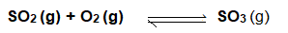
b. During contact process, sulphur dioxide gas react with oxygen gas to produce sulphur trioxide according to the equation:

- State any one condition necessary for the reaction
________________________________________________________________ (1 mark)
- Mention the type of reaction as indicated by the arrow
________________________________________________________________ (1 mark)
- Name the substance produced when sulphur trioxide is mixed with concentrated sulphuric acid
________________________________________________________________ (1 mark)
c. Using a chemical equation, describe the preparation of ethanol by hydration of ethene.
________________________________________________________________________________________________________________________________________________________________________________________________________________________________________________________________________________________________________________(5 marks)

SECTION B (30 marks)
Answer all the questions in this section in the spaces provided.
- a. Describe how salts prepared by precipitation are purified.
_______________________________________________________________________________________________________________________________________________________________________________________________________________________________________________________________________________________________________________________________________________________________________________________
(4 marks)
b. Describe an experiment that can be carried out to determine if reaction of hydrochloric acid and sodium hydroxide is exothermic or endothermic reaction.
___________________________________________________________________________________________________________________________________________________________________________________________________________________________________________________________________________________________________________________________________________________________________________________________________________________________________________________________________________________________________________________________________________________________________________________________________________________________________________________________________________________________________
(6 marks)
- a. Describe how the presence of sulphur dioxide can be tested using filter paper and potassium
dichromate solution.
________________________________________________________________________________________________________________________________________________________________________________________________________________________________________________________________________________________________________________________________________________________________________________________________________________________________________________________________________________________________________________________________________________________________________________________________________________________________________________________________________________________________________________________________________________________________________________________
(4 marks)
b. Describe the water cycle.
____________________________________________________________________________________________________________________________________________________________________________________________________________________________________________________________________________________________________________________________________________________________________________________________________________________________________________________________________________________________________________________________________________________________________________________________________________________________________________________________________________________________________________________________________________________________________________________________________________________________________________________________________________________________________________________________________________________________________________________________________________________________
(6 marks)
- Describe the process of soap making.
________________________________________________________________________________________________________________________________________________________________________________________________________________________________________________________________________________________________________________________________________________________________________________________________________________________________________________________________________________________________________________________________________________________________________________________________________________________________________________________________________________________________________________________________________________________________________________________________________________________________________________________________________________________________________________________________________________________________________________________________________________________________________________________________________________________________________________________________________________________________________________________________________________________________________________________________________________________________________________________________________________________________________________________________________________________________________________________________________________________________________________________________________________________________________________________________________________________________________________________________________________________________________________________________________________________________________________________________________________________________________________
(10 marks)
END OF QUESTION PAPER

